Glue integration databricks

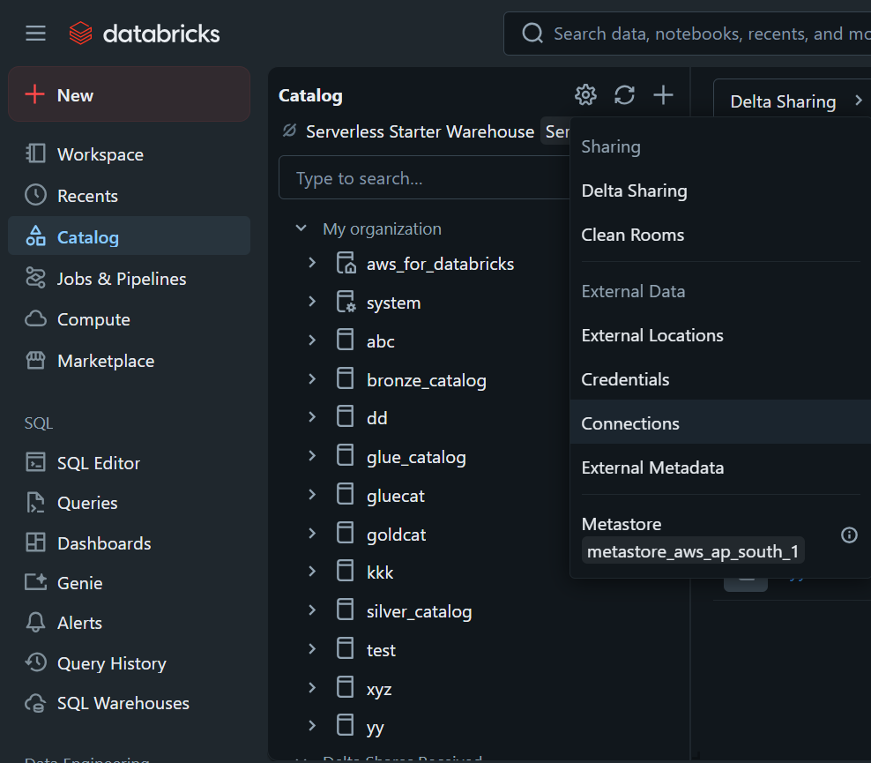

Step 2:

Create new connnections

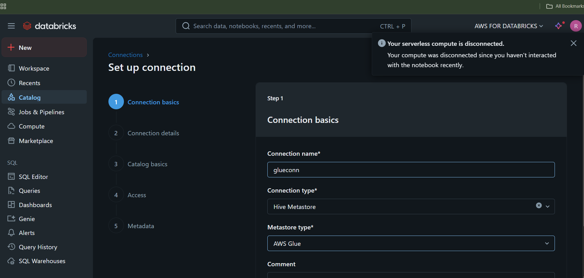

Provide aws glue information

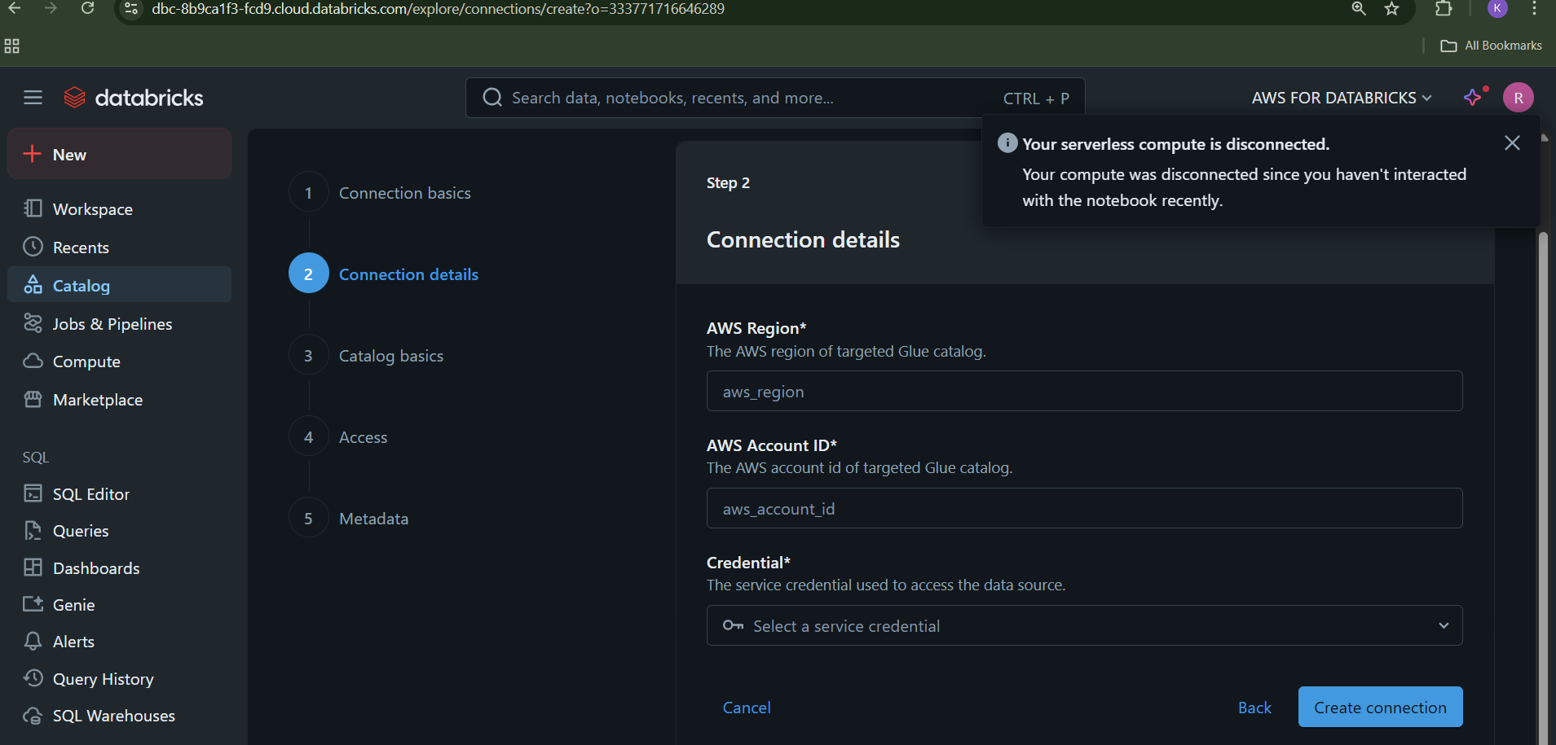

Next step catalog basics:

This step onwards it is same how to create catalog in databricks